Task 9 : Cloud networking Firewalls
1. In AWS, create a new security group named InstaClone-SG and configure it to allow incoming HTTP (port 80) and HTTPS (port 443) traffic only from your own IP address.
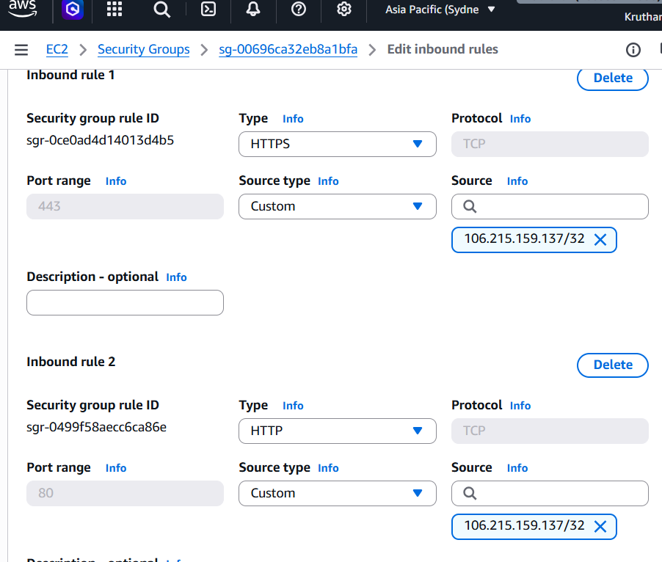
2. Set up a security group for a mock Zomato-style backend server that allows incoming MySQL (port 3306) connections only from a specific IP address and blocks all other inbound traffic.<br><br><em><strong>Hint:</strong> Use the 'Custom TCP' rule and specify the allowed IP in CIDR format.</em>
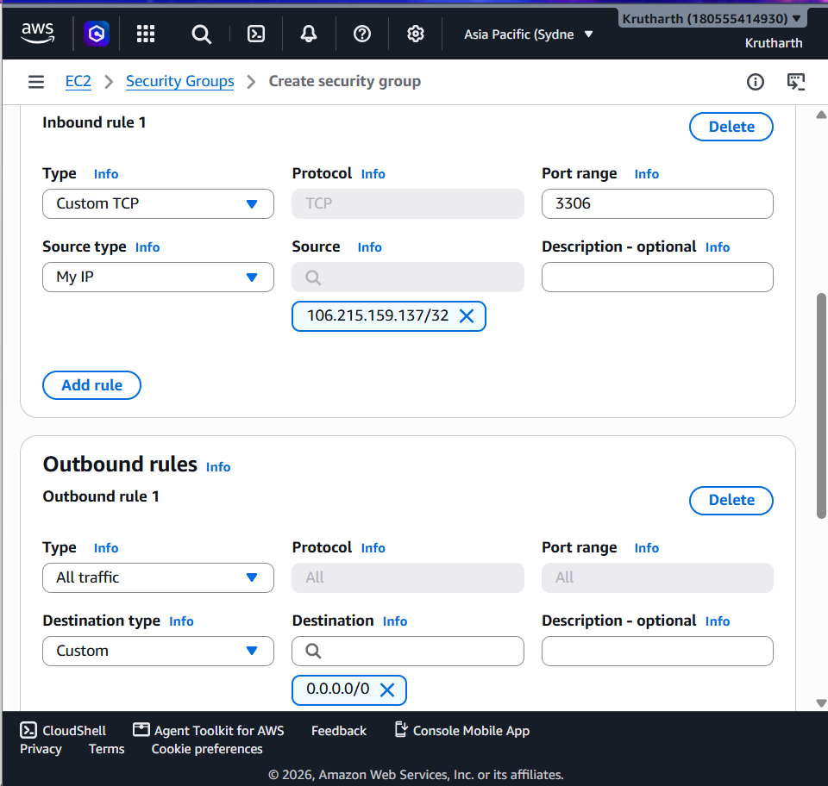

3. Modify an existing security group to block all outbound traffic except for DNS (port 53) and HTTPS (port 443) to simulate a strict Paytm wallet server environment.
Ans: Steps Performed.
1. Logged in to the AWS Management Console and opened the EC2 Dashboard.
2. Selected Security Groups from the left navigation panel.
3. Chose the existing security group to modify.
4. Opened the Outbound Rules tab and clicked Edit Outbound Rules.
5. Deleted the default All Traffic outbound rule.
6. Added the following outbound rules:
- HTTPS (TCP Port 443) with destination 0.0.0.0/0.
- DNS (UDP Port 53) with destination 0.0.0.0/0.
- (Optional) DNS (TCP Port 53) with destination 0.0.0.0/0.
7Saved the changes.
Result: After modifying the security group, the EC2 instance was allowed to send only HTTPS and DNS traffic. All other outbound traffic was blocked. This configuration simulates a secure Paytm wallet server, where only encrypted web communication and domain name resolution are permitted, reducing the risk of unauthorized network access.
4. Compare security groups and network ACLs by listing two key differences in how they control traffic for a Flipkart-like cloud application.<br><br><em><strong>Hint:</strong> Think about the level (instance vs subnet) and direction (inbound/outbound) each operates at.</em>
Feature | Security Groups | Network ACLs
Level of Operation | Operate at the instance level and are attached directly to EC2 instances. | Operate at the subnet level and control traffic for all resources within the subnet.
Traffic Handling | Stateful – return traffic is automatically allowed, regardless of outbound rules. | Stateless – inbound and outbound traffic must be explicitly allowed using separate rules.
Security Groups act as virtual firewalls for individual EC2 instances and provide fine-grained control over inbound and outbound traffic. They are stateful, which means responses to allowed requests are automatically permitted.
Network ACLs (Access Control Lists) provide an additional layer of security at the subnet level. They are stateless, requiring separate rules for both inbound and outbound traffic. In a Flipkart-like cloud environment, Security Groups protect individual application and database servers, while Network ACLs help secure the entire subnet by filtering network traffic before it reaches the instances.

